Storage Providers
Whenever a user uploads a document to DMX it is stored somewhere and served back to the user upon request. Until version 5.2 the documents are stored on the hard disk of the server under portals/[id]/DMX (or another location on disk if you chose). From version 5.2 you have the ability to choose the mechanism (referred to as a ‘provider’) with which the module stores its contents, i.e. where DMX stores the files uploaded by the users. In the current release there are 3 storage providers that allow you to store on disk (as before), in SQL, or using Amazon S3. To set the mechanism you go to the ‘Storage Settings’ screen found on the Admin menu of your DMX.
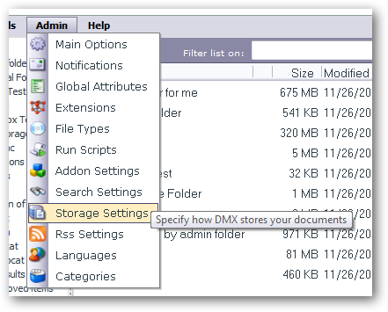

Disk File Storage Provider
This is the default storage provider and the one that used to be active in earlier versions of DMX. Files are stored on disk with hashed filenames to obscure them and the extensions are renamed to make them unavailable for direct download through IIS.
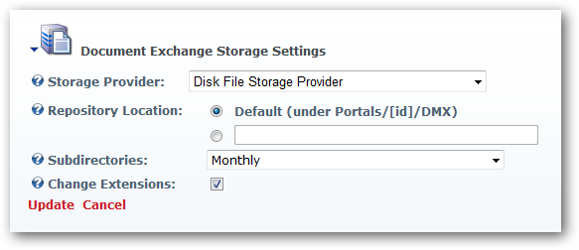
The settings specify the following:

Repository Location
The default is under portals/[id]/DMX, where [id] is the Portal ID of your portal. DMX stores a relative path to the document in the database. This means that if you’d like to move all disk stored content, you can as long as you observe the path following the ‘repository location’. So if a file is stored as ‘portals/0/DMX/2009/11/filename.resources’ and you’d like to move the repository to H:\mynewrep, then set repository location to ‘H:\mynewrep’ and make sure the existing files are moved to the new location preserving the paths so the aforementioned file would be stored as ‘H:\mynewrep\2009\11\filename.resources’. Then DMX is able to find it again.
Note: if you plan to store in another location than the default you must ensure adequate read/write permissions for the asp.net worker process to the new location. If storing in another place on the web server this is fairly straightforward. Check the identity under which the app pool of your web site operates (in IIS 6 this is normally NETWORK SERVICE) and set full access rights to the new location for this identity. If you plan to store on a network share (yes, this is possible, just define the location as ‘\\myserver\folderx’ etc) then it gets more tricky. Now you need to ensure the share server recognizes the web server’s app pool identity. What many don’t realize is that the NETWORK SERVICE account of server 1 is not the same identity as the NETWORK SERVICE account of server 2. So just giving full access to the own NETWORK SERVICE account will not grant access to DMX as it tries to save content. Instead, you’ll need a domain controller and set up the worker process to work under an account that both machines recognize.

Subdirectories
DMX does not create folders in the repository that reflect the actual folders defined in the module by the user. Instead, all documents are stored in the ‘repository’ as if it were one large container. To help keep the amount of files in a folder manageable in larger installations we can set subfolders to start at regular intervals. So setting this to ‘Monthly’ will make all files uploaded in November 2009 to be stored under 2009/11. The default setting is ‘Monthly’.

Change Extensions
By default, DMX not only renames the file to obfuscate it, it also renames the extension to .resources to tell IIS it should never serve the file. This is part of a 3 tier security model for disk storage, the last tier being the ability to set the repository to a location outside the web site’s root folder. These 3 tiers should ensure proper security for your files. The option to switch off the extension renaming was introduced to accommodate the Indexing Service search provider for DMX. Indexing Service is Microsoft’s search engine that’s internal to your Windows OS. It crawls the hard disks and is able to read the contents of some files and index them. The only requirement is that files have proper extensions so the service knows how to read them. So we have to switch off the extension renaming in DMX. Note that the default search provider in DMX, Lucene, does not need this. So unless you use the Indexing Service provider, we suggest you leave the checkbox checked.
Note: if you need to change at some point, there is a script under ‘Admin > Run Scripts’ on the DMX menu to change existing content. I.e. to rename the extensions of older files to either conform to Indexing Service requirements or back to default.
Note: if you do opt to not rename extensions we suggest you store the documents outside the DNN root (i.e. not in the default repository location).

SQL Storage Provider
Documents will be streamed to the SQL database that’s used by DNN/DMX. When you change to this provider and click ‘Update’ it runs the necessary SQL script to ensure the table (DMX_Repository) it needs is there.
There are no settings for this provider. Realize that the complete document goes into the database, so you’re likely to grow your database significantly. Also you should note that you can only use the Lucene search provider with this option.

Amazon S3 Storage Provider
You can now leverage the cloud for your DMX documents. When opting for this storage provider all documents will be stored on Amazon’s S3 cloud service. You’ll need to create an account with them first before you move on.
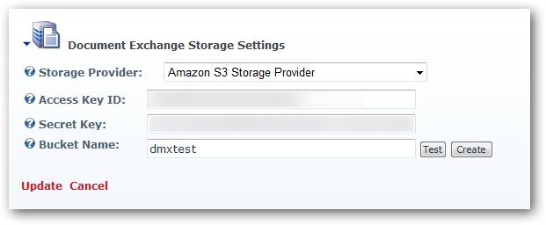

Access Key ID/Secret Key
This is your key to access your Amazon’s S3 service. You should have received these after you signed up for S3 (note that you need to sign up for S3 separately after creating an account with Amazon).

Bucket name
There is no hierarchical folder structure in S3, but your content is organized in a flat structure under what’s known as ‘buckets’. For your DMX you’ll specify what the name is of the bucket to use. You can create the bucket by pressing the ‘create’ button or manually in S3.

Moving Existing DMX Content
It is quite possible you want to switch from one storage mechanism to another at some point in time. For this there is a script which will move all existing content from ‘old’ storage providers to the one you’ve currently selected. So, if you’ve now selected ‘Amazon S3’ as your current storage provider then all content stored on disk or in SQL will be moved to Amazon S3 when running this script. The script is found under ‘Admin > Run Scripts’ and is called ‘Move Old Content To New Storage Provider’.
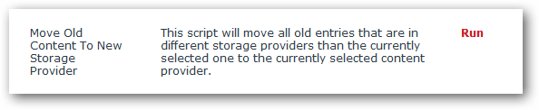

Fallback
The disk based storage provider is the least likely to fail. The S3 provider, however, would fail if Amazon is somehow unreachable. To make sure no document gets lost the storage logic attempts to store the document using the given storage provider first and if it fails will use the disk based storage provider as a fallback.

